Typical Pedimat Configuration

Instructions for creating a new quote – part II.

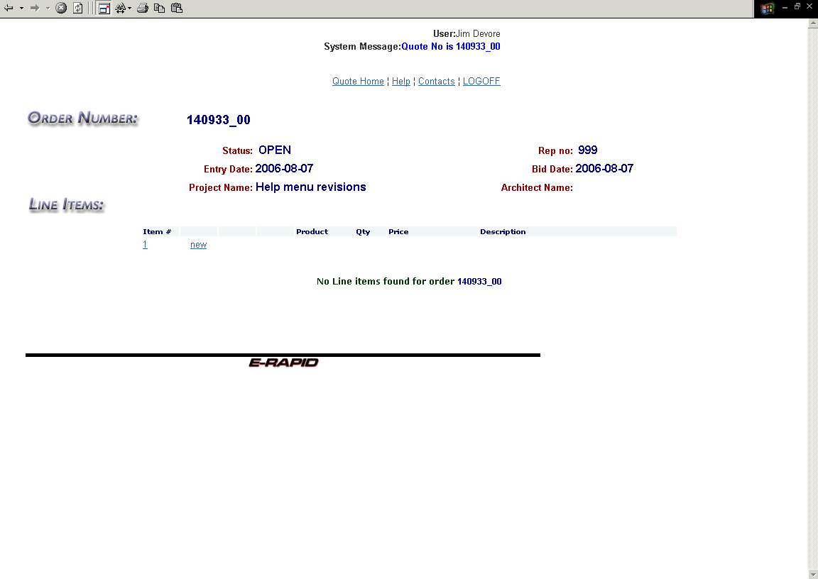

- This is the line item list. This screen directly follows the header screen. As products, or different line items, are created, they are added to this list.
- Press the F11 function key to get a full screen mode.
- To return to the header screen, click on the item # (number 1 in this example).
- Write down the quote number for future reference.
- Click on the blue “new” text to go to the configurator screen.

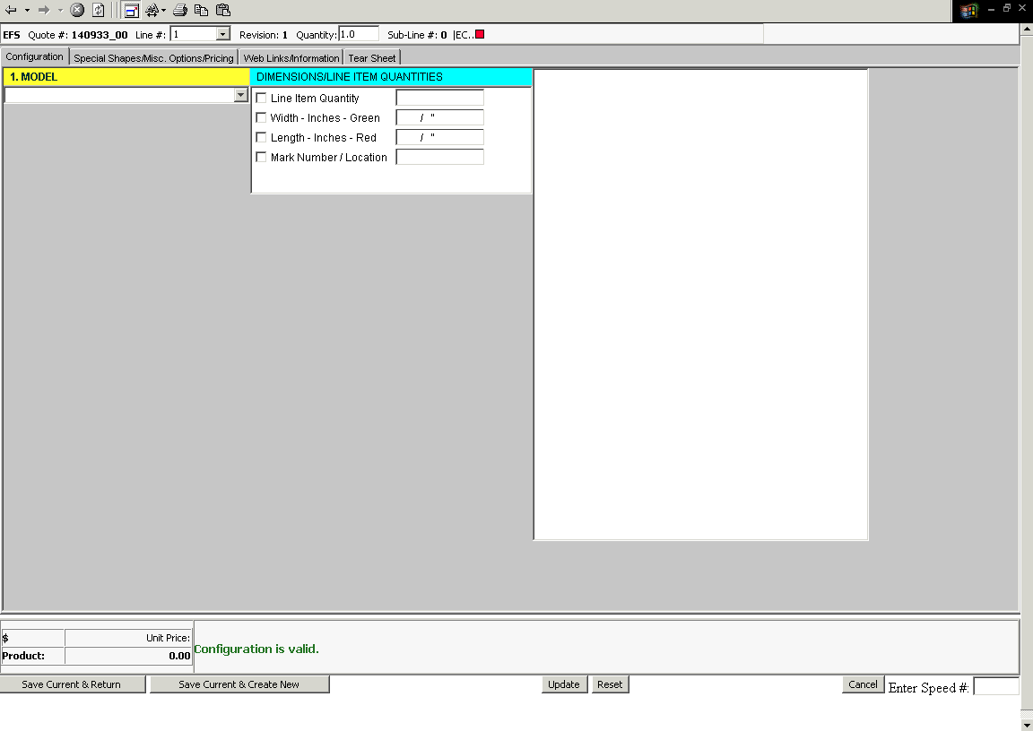
Note the four tabs at the top of the screen:
- Configuration – This is the area in which specific product information is added. For example; model number, quantity, size, and etc.
- Special Shapes/Misc. Options/Pricing – This is the screen in which special shapes, logo and insert color information is added. Also, pricing discounts are selected.
- Web Links/Information – This is the screen in which product information and custom line notes can be added.
- Tear Sheet – This is the screen that previews the printable tear sheet. You can add location and notes specific to the tear sheet here.

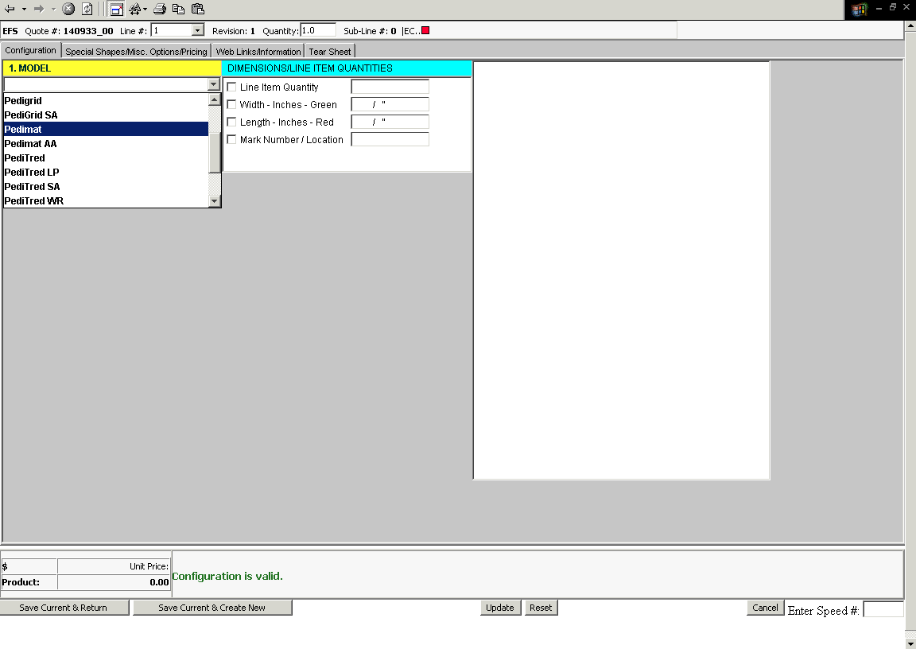
- Click on the drop down arrow at the right end of the Model block.
- Highlight and click on one of the sixteen models listed.

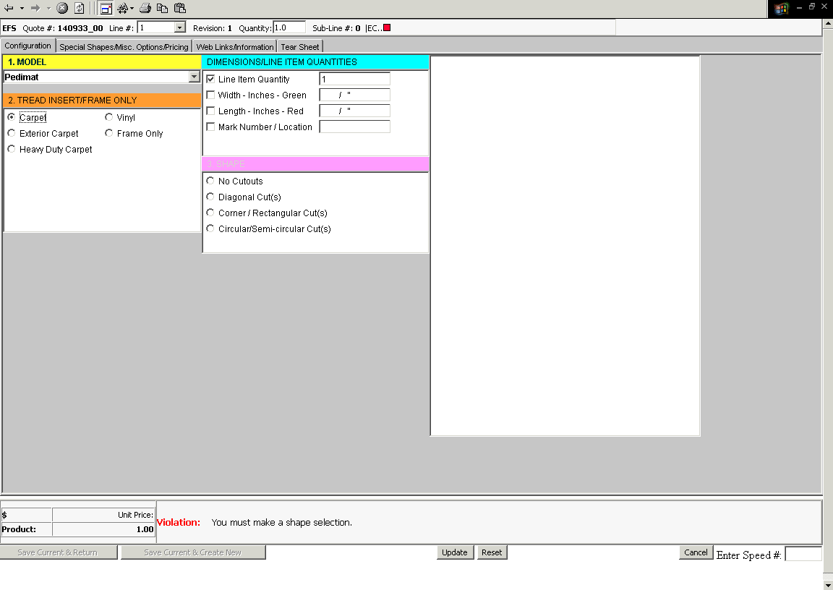
- Select one of the tread options (if applicable).
- Note the Violation box in the lower part of the screen. This is the area where violations or exceptions will appear. This box is also an instruction set to help you move through the program. Generally, this box will spell out the next selection required.
- Note that as you select the tread insert the next selection screen will appear.
- Select the “No Cutout” shape option for standard square or rectangular units.

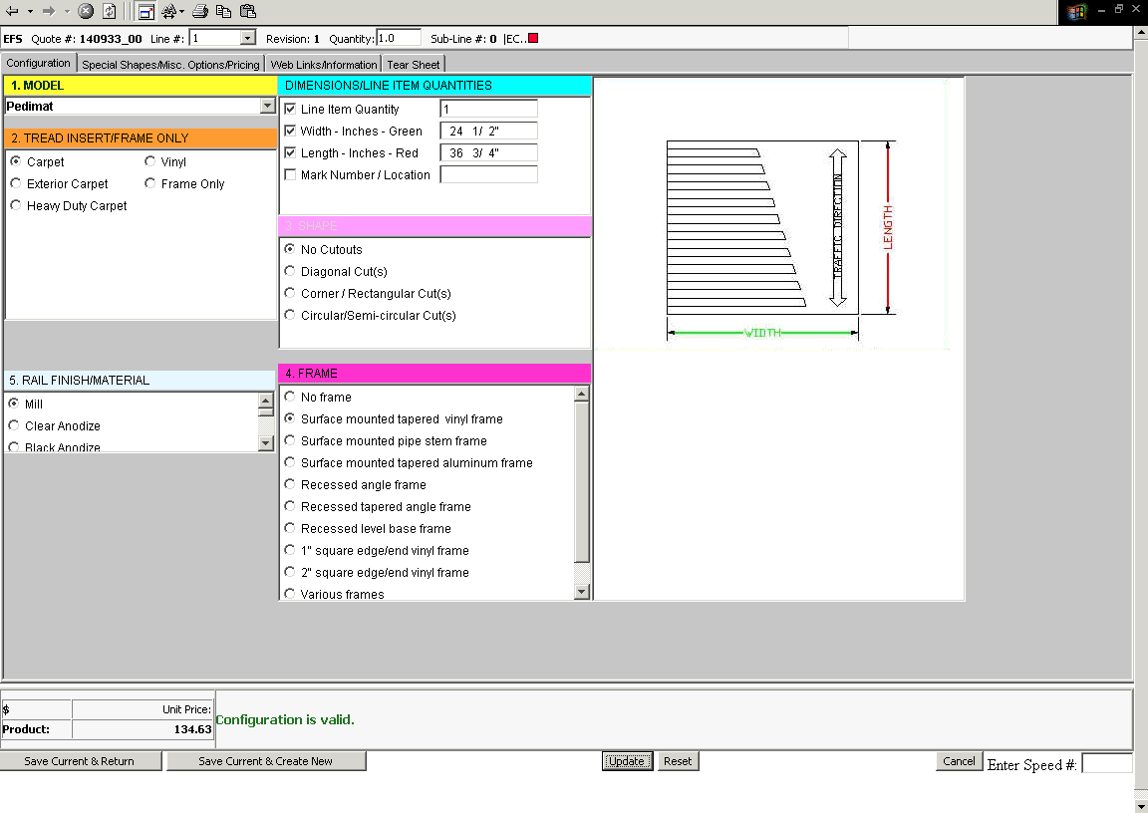
- Continue to select frame and finish as the selection boxes appear.
- Change the quantity required as necessary.
- Enter the Width and Length in inches. To enter a whole number, enter the inches then tab or use the mouse to click to the next field. To enter a fraction, for example 24 ½”, type in 24, space bar, 1, space bar, 2.
- To correct a width or length entry, click in the width or length box and reenter the data, or click on the width or length description to delete the entry and reenter as above.
- Hit the Update button in the lower center of the screen when selections are complete in order to view the pricing.
- When complete, the Violation box at the bottom will only show Warnings, Notes, or the green “configuration is valid”.

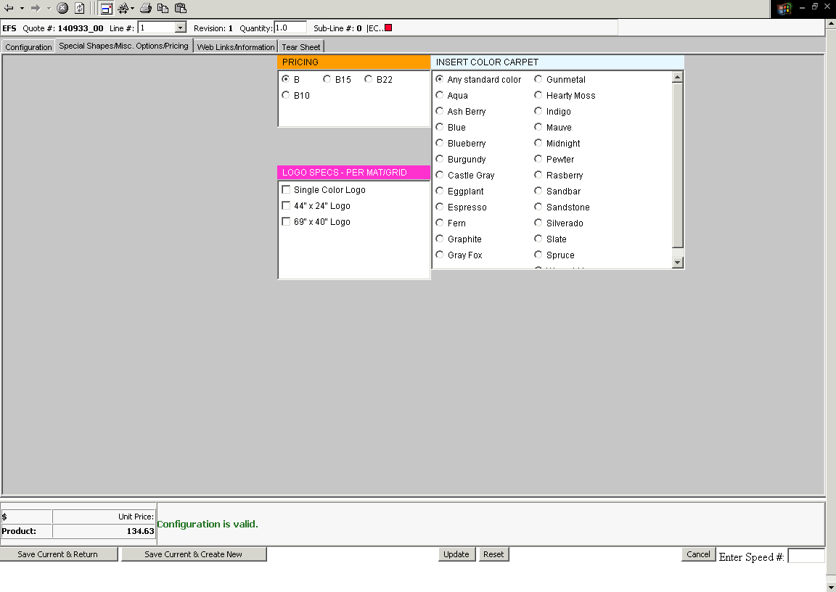
- Click on the Special Shapes/Misc. Options/Pricing tab (the tab at the top).
- Select insert color if known.
- Select Logo if required.
- Select special discount pricing if available for that model. The number following the “B” is the special discount percentage.
B = Book Full book price - Pays 15% commission.
B10 = Book less 10% - Pays 12% commission.
B15 = Book less 15% - Pays 10% commission.
B22 = Book less 22% - Pays 8% commission.

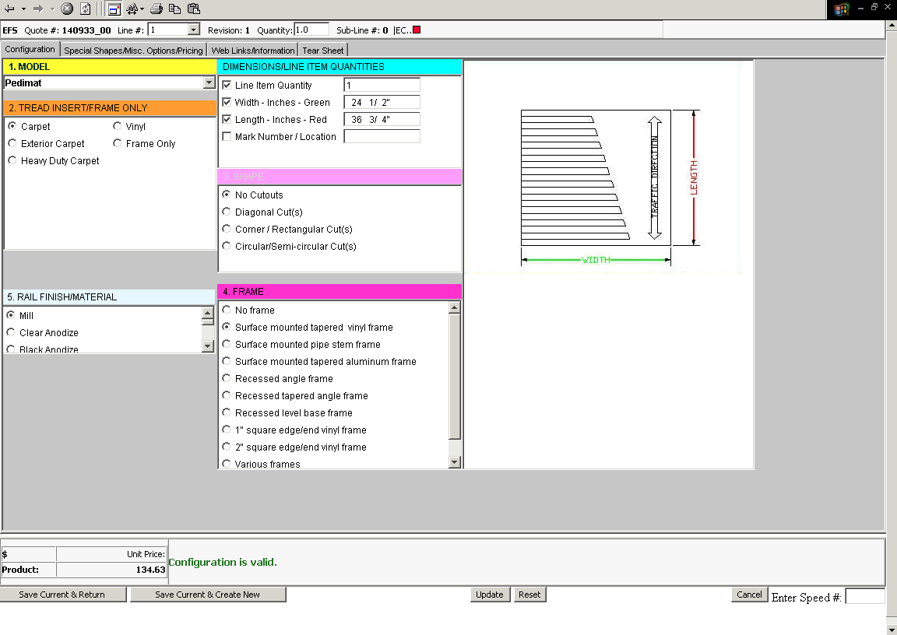
- After the configuration is complete, with no violations appearing, pick one of two options from the lower left of the screen:
- Save Current & Create New – Click on this to save the current configuration (model, quantity, size, etc.) and continue to enter additional configurations. The line number is incremented. Be sure to hit the “Reset” button on the lower middle of the screen when changing models.
- Save Current & Return – Click here to save this configuration and return to the line item screen to complete the quote process

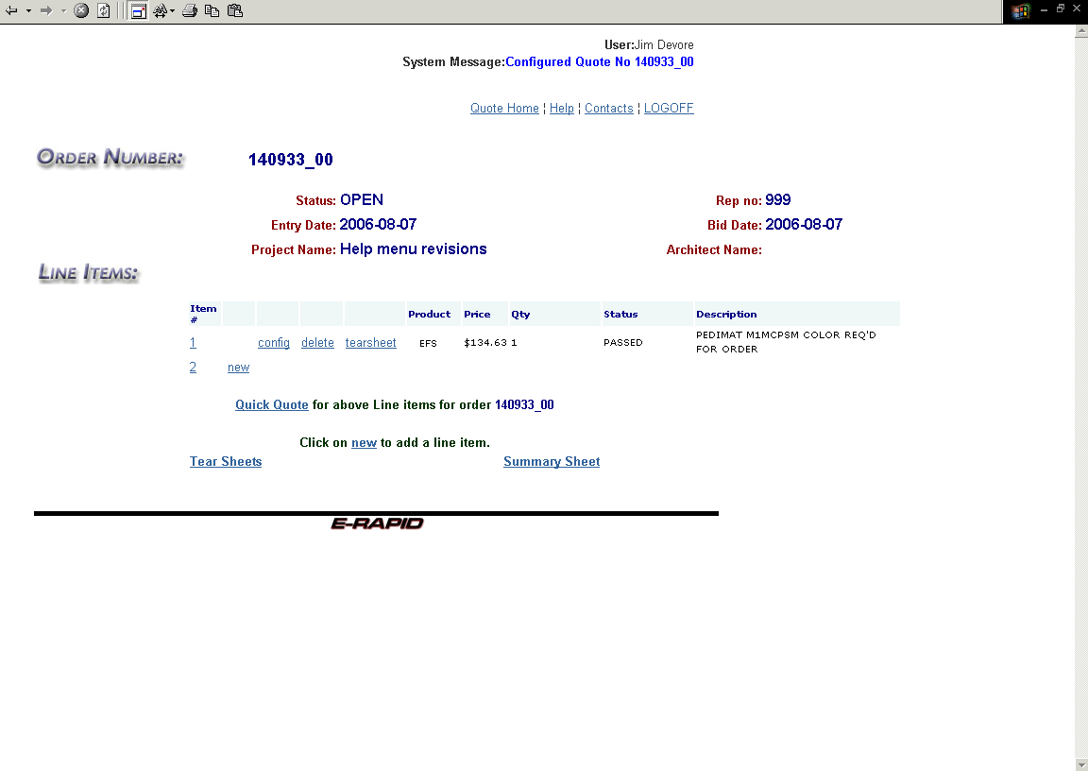
Choices for the next step:
- Click on the 1 or 2 in the “Item #” column to return to the quote header.
- Click on the “new” to enter a new configuration (model, quantity, size, etc.)
- Click on “config” to edit an existing line or configuration.
- Click on “delete” to remove an existing line.
- Click on “tearsheet” on the line to see the tear sheet for that line or “Tear Sheets at the bottom left to get tear sheets for all lines.
- Click on the “Quick Quote” option to continue to the calculation screen.

NOTE: If you see a red “Abort” error on this screen, the line has a major error and will not be included in the quoted sale price. Aborts should be corrected before proceeding.

NOTE: Once through the price calculator and the quotation has been retrieved, click on the “Summary Sheet” to get a file copy of the configured quote.

